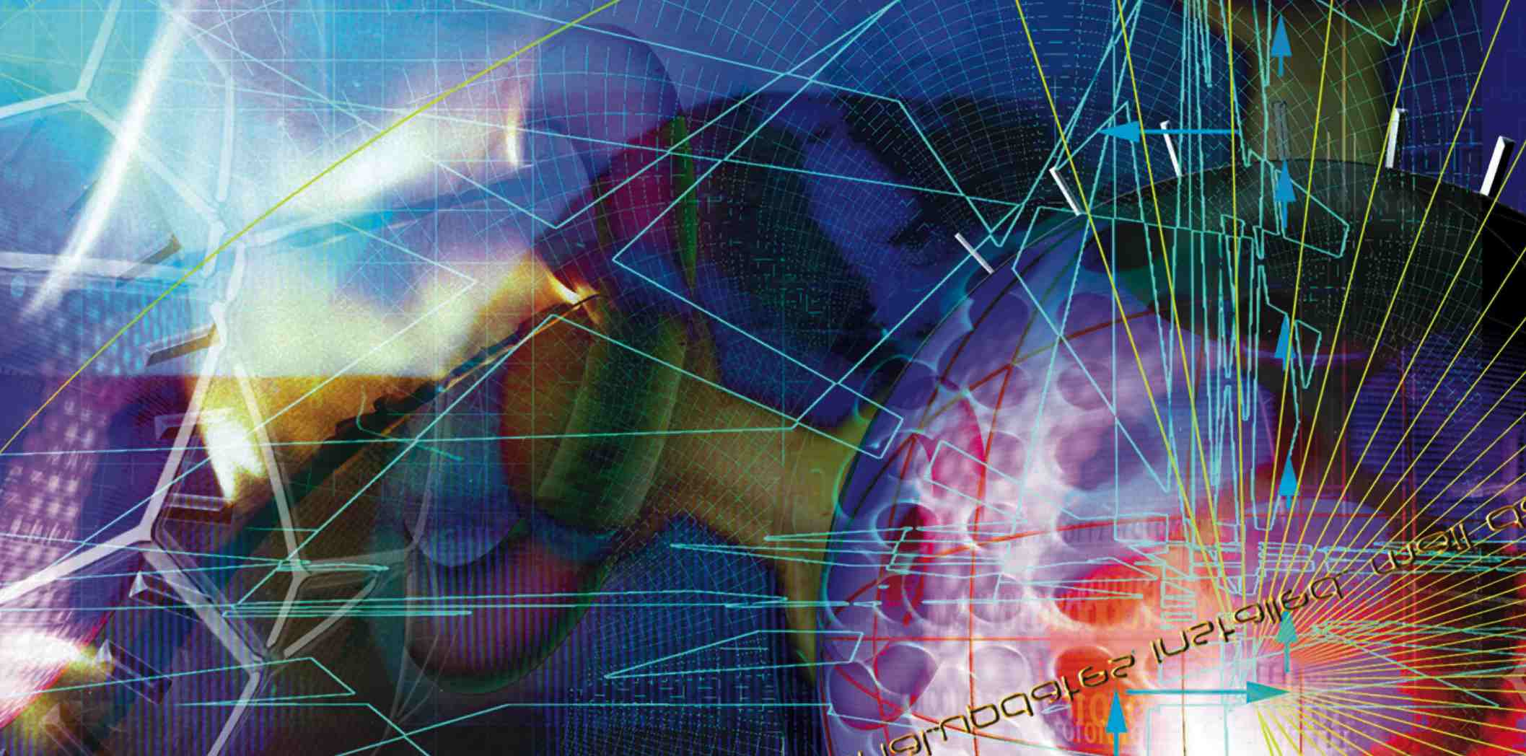

IEEE Charles Proteus Steinmetz Award
RECOGNIZING THE EXTRAORDINARY

For exceptional contributions to the development and/or advancement of standards in electrical and electronics engineering.

The IEEE Charles Proteus Steinmetz Award was established by the Board of Directors in 1979.

PRESENTED TO - An individual

PRIZE - Recipient will receive a bronze medal, certificate, and US$10,000 honorarium.

SPONSOR – IEEE Standards Association
Nomination information can be found at:
http://www.ieee.org/about/awards/tfas/steinmetz.html

Nomination Deadline:
15 January (Annually)
Selection criteria include:
(a) Engineering and administrative accomplishment and responsibilities

(b) Publications (books, standards, papers, conferences)

(c) Honors

(d) Supporting letters

(e) IEEE Activities, other organizations

