Short Bios : IEEE-SA Fellowship Program Participants at IEEE 802 Plenary
4-9 March 2018 in Rosemont, Illinois, USA

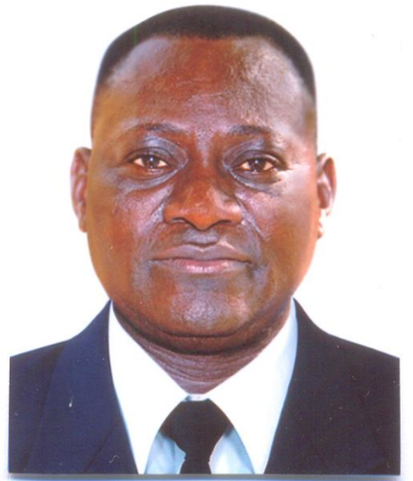
Mr. Richard ANAGO is a telecommunications engineer and has more than 25 years of experience in the public and private telecommunications sector in Burkina Faso.
He holds a degree as a telecommunications design engineer, obtained in July 1989 with honors, from the Higher Institute of Electronics and Electrical Engineering of Sofia (Bulgaria). After completing his national development service as a teacher at the Technical High School in Ouagadougou, he joined the National Telecommunications Office of Burkina Faso (historical telecommunication operator) where, for 15 years, he held several positions with responsibilities in the areas of development, standardization, network planning, policy, network regulation, and international cooperation management.
Since January 2007, Mr Richard ANAGO has been appointed by decree from the Council of Ministers as Director of International Affairs and Cooperation at the Ministry of Telecommunications of Burkina Faso. As such, his duties and responsibilities essential to this position are summarized as follows:
- Prepare, monitor and implement international agreements, treaties and conventions concerning the development of telecommunications to which Burkina Faso is a party;
- Monitor activities related to Burkina Faso's participation in specialized institutions and organizations.
- National dissemination of recommendations, standards and resolutions taken by international institutions of the sector to national actors concerning the development of telecommunications policies and infrastructures.
- Preparation and dissemination of statistical data of the ICT sector in relation to international institutions.
He speaks fluent French and Bulgarian and is fluent in English.
Mr. ANAGO has been a Knight of the National Order of Burkina Faso since 2015 and is married with two (2) children.
IEEE 802 areas of interest: 802.1 (Higher Layer LAN Protocols), 802.24 (Vertical Applications TAG)

***


Dr. Ramy Ahmed Fathy, PhD

Mr. Ramy Ahmed Fathy is the Director of Digital Services Planning and Risk Assessment at the Egyptian National Telecom Regulatory Authority (NTRA). As the Director of Digital Services, he seeks development and implementation of sustainable and effective digital services in the Egyptian market. His role at NTRA includes the development of guidelines, regulatory frameworks, viable business models, and effective specifications & technical operating parameters that ensure efficient and effective operation of services. He is leading the design, and specifications development of intelligent and digital services, addressing interoperability, risk, regulatory impact assessment, and market adoption while employing a wide set of tools related to radio network planning, transport design, market modeling, and optimization.
Fathy has been actively involved at different stages of development of various intelligent ICT systems and services in addition to numerous ICT-for-development and digital transformation initiatives, including national broadband networks, smart cities, m2m and IoT enabling regulatory frameworks, smart utilities, eGov, water management, and next-generation access planning. His 15 years of experience include projects design, budgeting, and planning of smart cities, enterprise automation, DTV transformation, and Intelligent Transportation Systems (ITS).
Over the past 10 years, Fathy has served in key roles in the international standardization arena. In 2012, he served as vice-chair of the ITU-T Focus Group of Bridging the Gap between Innovations and Standardization (Focus Group Innovation). One year later, he was elected as chair of the ITU-T Focus Group on Smart Water Management for a period of two years. Since late 2015, he has also served as vice chair of the ITU-T Study Group 20 (SG20) on IoT and its applications including smart cities and communities, where he is leading activities related to the standardization of end-to-end architectures for IoT and smart cities, intelligence, mechanisms for the interoperability of IoT applications, security, and identification aspects of IoT systems.
Fathy has a PhD in electronics and communications. He has led R&D projects in radio network planning and optimization, cognitive radio systems, video coding, cryptography, DSP/FPGA/GPP based implementations of consumer electronics products, and satellite communication systems. He has numerous publications in esteemed journals and conferences, and he is the author of one book in electronics.
IEEE 802 areas of interest: 802.11 (Wireless LAN), 802.15 Wireless Personal Area Network, WPAN), 802.24 (Vertical Applications TAG)
***

Ms. Caroline Koech is the ICT Liaison Manager at the East African Communication Organization (EACO), whose mission is to promote policy harmonization and development of the ICT sector in the five East African Community Member States. Caroline is involved in various projects and programs in the East Africa region. Before joining EACO in 2012, she served as a network engineer and project manager in Safaricom Kenya.
Caroline holds a Master of Science in information systems from the University of Sunderland, UK, and a Bachelor of Science from the University of Nairobi, Kenya. Caroline is a certified Prince2 Project Management Practitioner and Program for Management Development (PMD) certified from Strathmore University, Kenya.
IEEE 802 areas of interest: 802.18 (Radio Regulatory TAG), 802.19 (Wireless Coexistence), 802.22 (Wireless Regional Area Networks), 802.24 (Vertical Applications TAG)
***
Mr. Lloyd Matabishi currently works for Zambia Information and Communication Technology (ZICTA) as a Spectrum Engineer-Planning and Licensing. His job is to plan and license the usage of the radio spectrum in Zambia. This also includes spectrum regulations and policies activities for Zambia and regional organizations such as SADC and ATU; and development and adoption of radio standards in Zambia, including IEEE 802 wireless standards. He is also engaged in research to promote economic and technical efficient usage of the radio spectrum. He is a member of the IEEE Standards Association, IEEE Communications Society, and IEEE Electromagnetic Compatibility Society and he is a Registered Engineer with the Engineering Institute of Zambia (EIZ).
He has more than 10 years working experience in radio spectrum regulation and policy as a radio spectrum engineer; 5 years’ experience in spectrum monitoring and compliance (July 2007-Sep 2012) and 5 years’ experience in spectrum planning and licensing (Oct 2012 to present). Mr. Matabishi also worked for a year as a telecommunication officer at the Zambian government ICT policy maker, the Ministry of Communication & Transport (2006-2007).
He is also a member of the National Technical Committee on Telecommunication Standards in Zambia. He has been involved in the adoption of many wireless standards in Zambia. He developed the guidelines for the usage of unlicensed spectrum in Zambia to promote coexistence of unlicensed radio systems.
He obtained his Bachelor of Engineering degree in electronics and information engineering from Huazhong University of Science and Technology, People’s Republic of China (June 2004). He has a Certificate in international communication policy and regulations (May 2017) from American University Washington College of Law & International Telecommunication Satellite Organisation (ITSO) and is currently pursuing a Master’s of Law (LLM) in ICT from Open University of Tanzania with the sponsorship of United Kingdom Telecommunication Academy (UKTA).
Attending the IEEE Standards Fellowship Program will be relevant to his work because he is involved in spectrum regulations and policy not only in Zambia but also in other regional organizations such as SADC/CRASA and ATU. This program will help him learn more on the IEEE 802 wireless standards and technologies including best practice of IEEE 802 radio regulations so that he can promote coexistence of unlicensed spectrum in Zambia and Africa to support development and deployment of broadband wireless networks.
IEEE 802 areas of interest: 802.11 (Wireless LAN), 802.16 (Broadband WIreless Access), 802.18 (Radio Regulatory TAG), 802.19 (Wireless Coexistence)
***
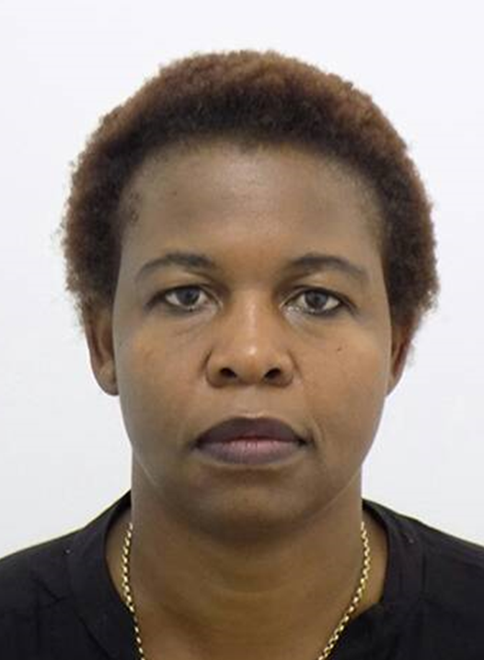
Mrs. Rudo Mudavanhu is a seasoned telecommunications expert and holds a Master in business administration (MBA) from the University of Zimbabwe. She has an Executive Diploma in management for executives from the University of Zimbabwe and another Diploma in computer analysis and systems design. In 2010 she became the first-named ICT Business Woman of the Year by the Ministry of ICT and recently in 2014 was recognized by the Women’s Heritage Trust, an international unit that recognizes women’s contribution into society.

Rudo is a business leader in advancing and bridging the digital divide within Africa and Zimbabwe, in particular through use of ICTs. She leads Africom Holdings, a company licensed in terms of the Postal and Telecommunications Act Chapter (12.05) to provide Zimbabwean internet access services (License No. IAPA201005015). Africom provides wireless and wire-line internet through various technologies such as fiber, CDMA, Wimax, and other new technologies. Her purpose is to lead the transformation of livelihoods through technologies using the internet as the key enabler.

The IEEE Standards Fellowship Program will mutually prepare both IEEE 802.18 and Rudo in formulating upcoming standards that can expedite bridging of the digital divide from both a Zimbabwean and African perspective. The following standards have been used by Rudo in her business technologies: 802.11, 802.11 (3.5ghz variants), 802.16d, 802.16e, and wire-line network using 802.1q.
IEEE 802 areas of interest: 802.11 (Wireless LAN), 802.19 (Wireless Coexistence), 802.22 (Wireless Regional Area Networks)
***

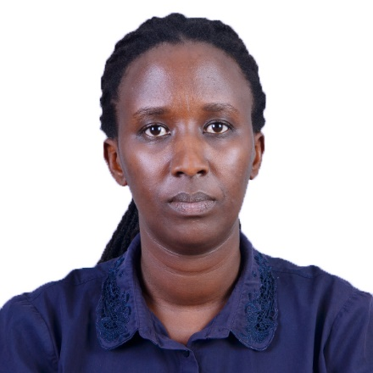
Ms. Yvonne Umutoni holds a Master’s degree in communications networks and software from University of Surrey, Guildford, United Kingdom (UK) and a Bachelor’s degree in electronics and telecommunication engineering” from University of Rwanda, College of Science and Technology, Kigali Rwanda.
She joined Rwanda Utilities Regulatory Authority (RURA) in August 2007, where she developed the “national numbering plan” for Rwanda and enforced implementation of this plan in the Rwandan telecom market. In 2010, she was involved in the development of interconnection costing model for monitoring and enforcement of interconnection rate for the telecom industry in Rwanda. Since 2011, she has been actively involved in performing audits (drive testing, hot spots measurements), benchmarks, and data analysis of quality of service (QoS) of cellular mobile networks and internet for telecom operators and ISPs in Rwanda. From 2012 to 2017, Umutoni was involved in editing and reviewing RURA Annual Reports for fiscal years 2011–2012 to 2016 – 2017.
She has worked and collaborated with different organizations and companies at international and regional levels.
Umutoni has chaired the ITU-T Quality of Service Development Group (QSDG) since 2012. She also serves as vice-chair of ITU-T SG12, leading group on performance, QoS and QoE and rapporteur of Question 12/12 on “Operational aspects of telecommunication network service quality.” Moreover, she edited three ITU-T standards:
- ITU-T Recommendation Y.1545.1: Framework for monitoring the quality of service of IP network services;
- ITU-T Recommendation Y.1545: Roadmap for quality of service of interconnected networks using internet protocol;
- ITU-T E.800 Supplement 10: QoS/QoE framework for the transition from network oriented to service oriented operations.
At the regional level, Umutoni is currently the vice-chair of the EACO WG03 on ICT Applications, Consumer Protection Issues and Cyber Security. From 2013 to 2017, she likewise chaired EACO WG9 on Quality of Service and Consumer Affairs.
IEEE 802 areas of interest: 802.11 (Wireless LAN), 802.19 (Wireless Coexistence)

*** *** ***

