IEEE 802 |  |  |  | Paul Nikolich
Local and Metropolitan Area Network Standards Committee |  |  |  | Chair, IEEE 802 LMSC
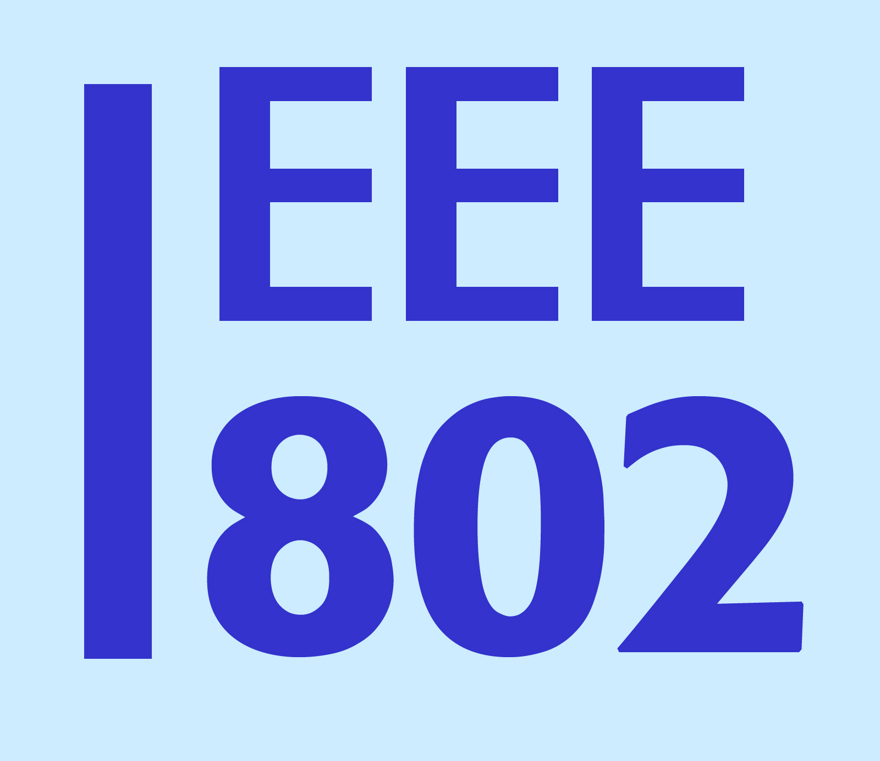 |  |  |  | 3 Barberry Way
 |  |  |  | Essex Fells, NJ 07021
 |  |  |  | cell: 857.205.0050
To: | Marlene H. Dortch, Secretary  Federal Communications Commission  445 12th Street, NW  Washington, DC 20554 |  | CC Julius Knapp via email
Subject: | In response to FCC Public Notice DA 15-516
Date: | 19 October 2015

Dear Ms. Dortch:

As chair of the IEEE 802 LAN/MAN Standards Committee (LMSC) Sponsor, I write to express the view of the IEEE 802 LMSC Sponsor’s continued desire for collaboration among organizations to ensure fair and reliable coexistence with other unlicensed technologies such as variations of LTE in unlicensed spectrum (e.g., LTE-U, LAA) .

At an August 29th Coexistence Workshop hosted by 3GPP, (the organization designing License Assisted Access) IEEE 802 was invited to present its views alongside 3GPP RAN and others. The material presented by IEEE 802 at this meeting is attached for your information.

IEEE 802 recommended that 3GPP adopt a number of specific 802.11-like coexistence features, and that those features be a mandatory part of the LAA standard, given how successful these features have been in promoting the growth of wireless broadband over unlicensed spectrum.

IEEE 802 requested that 3GPP provide the IEEE the opportunity to review, comment and influence the 3GPP LAA specifications before the March 2016 freeze date. It is IEEE 802’s understanding that 3GPP will announce its draft LAA specification available for external review in Q4 2015. At that point, IEEE 802 expects to review 3GPP’s draft LAA specification and provide any appropriate feedback, and we hope that input will be incorporated into the LAA specification, due with 3GPP’s Release 13 in March 2016.

Thank you for consideration of this information. If there are any questions, please contact me.

/s/ Paul Nikolich

Paul Nikolich
Chair, IEEE 802 LAN/MAN Standards Committee
p.nikolich@ieee.org

