IEEE P802.18
Radio Regulatory

Project | IEEE P802.18 consultation to regulatory bodies
Title | IEEE 802 Comments to Ofcom SFR Implementation Plan Consultation
Date Submitted | [17 March, 2005]
Source | [Michael Lynch]  [IEEE 802]  [802.18]
Re: | This document is the IEEE 802 is a response to the Ofcom call for consultation on the Spectrum Framework Review (SFR) Implementation Plan.
Abstract | This doc contains the IEEE 802 response to selected questions within the Ofcom SFR Implementation Plan Consultation.
Purpose | The purpose of this document is to provide a response to Ofcom on behalf of IEEE 802.

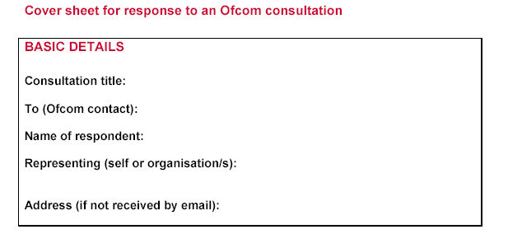
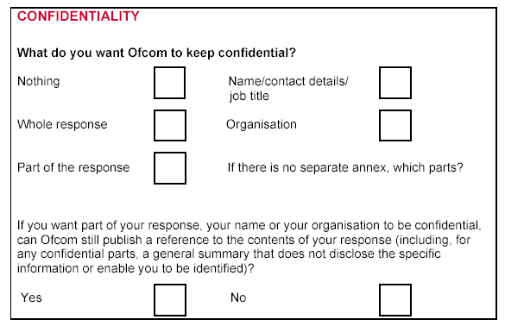
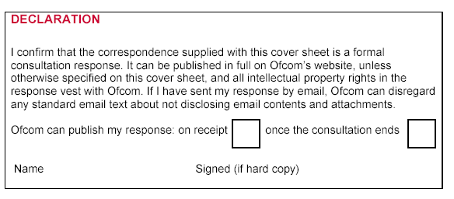

Professor William Webb:
The IEEE 802 appreciates the consideration of this document by Ofcom. In this document we are offering views of IEEE 802 which we hope will constructively add to the body of knowledge being considered on this subject.
IEEE 802 applauds Ofcom for the forward thinking displayed by this consultation. The IEEE 802 looks forward to working with Ofcom on future consultations.

Responses to Ofcom Implementation Plan Questions
Question 4.2 Do you agree future auctioned licences be for a minimum fixed term with a rolling extension?

IEEE 802 agrees that the auctioned licenses should be for a minimum fixed term that has the requirement for certain parameters to be achieved during this period.

These parameters could include such criteria as:
- Percentage of system installed
- Percentage of coverage area completed
- Number of users on the system
Question 4.5 Do you agree these are relevant consideration which Ofcom should take into account in devising its programme of spectrum awards?
A consideration that appears to be missing in Ofcom’s spectrum auction plans is an incentive for new technology development, as much of the efforts appear to address substitute services. New communications technologies with improved spectrum efficiencies should be provided an auction advantage to encourage their development/deployment.
2500 – 2690 MHz
Question 5.16 Is a technology neutral award the right approach for the award of 2500 – 2690 MHz?

IEEE 802 believes that administrations have a responsibility to enable innovative technologies and are encouraged by the UK’s progressive thinking with respect to licensing in the 2.5 -2.69 GHz band.
While there may be opposition to releasing the band under a “technology neutrality” regulatory framework, this needs to be balanced with the positive benefits from enabling competition and removing anti-competitive barriers.
Further European activities should be undertaken to encourage other administrations to progressively move to a more flexible regulatory framework. IEEE 802 supports the UK in their efforts within Europe to positively ensure any Decision does not preclude flexibility. We are aware of ongoing developments within CEPT and ITU in pursuit of a channel plan for the 2.5 – 2.69 GHz band. We believe that while there is a general perception that 2.5 – 2.69 GHz could be split into 2 X 70 MHz for FDD and a 50 MHz centre gap for TDD, administrations should also consider the possibility of proactively allowing operators the flexibility to deploy TDD within FDD allocations.
IEEE 802 believes that forcing any guard band requirements to come from the 50 MHz centre gap disadvantages TDD with respect to FDD. Consideration should be given to sharing any guard band requirement equitably.
Question 5.17 Do you consider an auction in 2006/7 appropriate?

IEEE 802 supports the Ofcom proposal to adopt the second option, namely: ”wait until the position on any binding EU harmonisation measures are clear (we anticipate that we may get this clarity by mid 2005) and award the spectrum by auction in 2006/7 for use from 1/1/2007 on as flexible a basis as allowed by such binding measures.”

IEEE 802 recommends that every effort be made to ensure that the EU harmonised measures enable this. Qtherwise, a concerted lobbying effort with the European Commission and a resulting European Mandate could be required.

Removing restrictions on the use of spectrum for mobile services
Question 8.1 Do you have any views on the approach that Ofcom should take to restrictions that prevent the use of spectrum for mobile services other than 3G?
IEEE 802 believes that restrictions that prevent the use of spectrum for mobile services other than 3G should be limited to technical considerations such as sharing criteria. Other limitations should be removed as soon as practical.
Question 8.2 Do you have a view on whether Ofcom should impose restrictions on new spectrum licences to prevent use of the spectrum for mobile services other than 3G?
IEEE 802 believes that restrictions on new spectrum licenses should be limited to technical considerations.
Question 8.5 Do you consider that the criteria used above are the most relevant considerations in relation to the potential removal of restrictions on offering 3G mobile services? Do you have any views on the approach that Ofcom should take towards removing restrictions in existing spectrum licences that prevent use of the spectrum to provide 3G mobile services? Which of options 1-4 above do you think offers an appropriate balance between those considerations that are relevant?

IEEE 802 supports the Ofcom proposal to adopt option 2, which would remove restrictions in 2007. We support efforts to allow flexibility in usage, especially with respect to allowing mobility in frequency bands originally identified for fixed and nomadic use but recommend that sufficient time is taken to enable appropriate sharing studies (if needed) to be performed. We believe that removing the restrictions in 2007 would be desirable and allow sufficient time to complete any necessary regulatory analysis and studies.

IEEE 802 believes administrations should remove constraints on how spectrum can be used, taking into account the implications of change of use which might necessitate additional technical analysis with respect to coexistence. Providing operators and users with flexibility, including mobility, is desirable; however, mobility performance is a direct function of frequency band. Hence, it is also important to continue to pursue access to lower frequency spectrum already identified for mobility, since some European countries are proposing to prevent innovative technological solutions being deployed, e.g. IEEE 802.16, in 2.5 – 2.69 GHz.
Question 8.7 Ofcom seeks views from interested parties on the approach that it should take to the award of new licences (other than in the 2010-2025 MHz and 2500-2690 MHz bands), and whether these should contain any restrictions as to use of the spectrum to offer 3G services. Do you have any views on which of the options discussed offers the most appropriate balance between relevant considerations?

As stated above, IEEE 802 believes that restrictions on new licenses should be limited to technical considerations only.

