IEEE P802.18
Radio Regulatory

Project | IEEE P802.18 consultation to regulatory bodies
Title | Working Document to Ofcom SFR Response
Date Submitted | [16 March, 2005]
Source | [Michael Lynch]  [IEEE 802]  [802.18]
Re: | This doc contains working text intended as a response to the Ofcom call for consultation on the Spectrum Framework Review (SFR).
Abstract | [This doc contains working text intended as a response to the Ofcom call for consultation on SFR.]
Purpose | [The purpose of this document is to provide a response to Ofcom on behalf of IEEE 802.]
Notice | This document has been prepared to assist the IEEE P802.18. It is offered as a basis for discussion and is not binding on the contributing individual(s) or organization(s). The material in this document is subject to change in form and content after further study. The contributor(s) reserve(s) the right to add, amend or withdraw material contained herein.
Release | The contributor acknowledges and accepts that this contribution becomes the property of IEEE and may be made publicly available by 802.18.

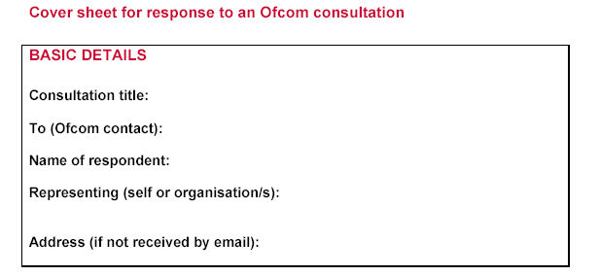
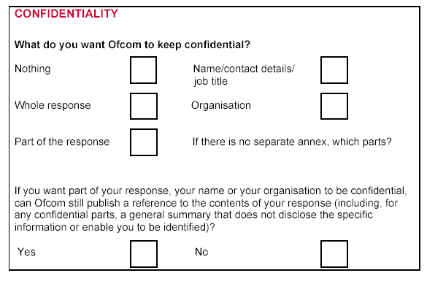
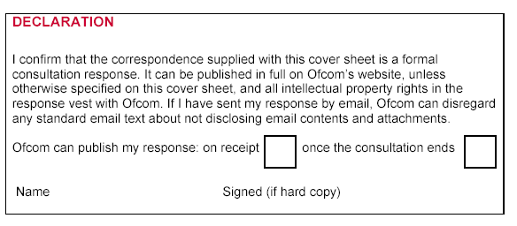

Professor William Webb;
The IEEE 802 appreciates the consideration of this document by Ofcom. IEEE 802 understands the original due date was February 15, 2005 and that consideration of this document is at the discretion of Ofcom. In this document we are offering views of IEEE 802 which we hope will constructively add to the body of knowledge being considered on this subject.
IEEE 802 applauds Ofcom for the forward thinking displayed by this Framework Consultation. The concern exhibited by Ofcom about a valuable resource is obvious in the tone and content of this document. The IEEE 802 looks forward to working with Ofcom on future consultations.

Questions from Document with IEEE 802 answers.

Q1: Are there any other major medium- to long-term spectrum management issues that this review should be considering? Are there any other significant technological or market developments that this review should be aware of when developing its thinking?

The IEEE 802 and other bodies are continuously evolving radio transmission and modulation methods. For example,
  - The IEEE 802.18 group would like to bring to Ofcom’s attention a new group that has started under the 802 umbrella. This is 802.22, which is concentrating on developing a standard for the re-use of TV Bands spectrum. The primary users and industry are working together to come up with viable solutions for the effective use of fallow or under-utilized TV bands spectrum. The initial program intends to find cognitive, licence exempt methods of coexisting with TV broadcast signals for fixed wireless broadband distribution.

Q2: Do you believe it is useful to publish a compendium of issues? How frequently should it be published? What information should be included?

A. It is useful to publish a compendium of issues and this may be best served on an annual basis. Accordingly, there would be more opportunity for feedback and the changes to spectrum policy would not make up such large queues, causing regulatory bottlenecks and slow response to market issues.

Q3: Are there any other issues of sufficient significance to merit mention in this document?

A. We would invite Ofcom to designate an official liaison to relevant IEEE 802 groups.

Q4: Are there important lessons to be learnt from experience in other countries that is not addressed here?

A. No Comment

Q5: Do you agree with Ofcom’s intent to maximise the use of trading and
liberalisation?

A. No Comment

Q6: Are there other areas, apart from those identified above, where trading and liberalisation should be restricted? Are there areas identified above where you believe the trading and liberalisation could be fully implemented?

- Where liberalization is implemented, Ofcom should review the spectrum interference requirements before a change of use is granted.

Q7: Do you agree with Ofcom’s approach to providing spectrum for licence-exempt use?

- While the consultation describes what appears to be a good model for predicting usage for 5-10 years, our recommendation is that the issue of licence exempt spectrum usage be reviewed on a regular basis to account for changes in technologies, applications and demand. For instance,

- Unlicensed applications are changing rapidly and new applications like security, voice and video may require more dedicated bandwidth per connection.
- Technological advancements may improve efficiencies and will require flexible rules for implementation.

Q8: Is Ofcom’s proposed methodology to estimate the amount of spectrum needed likely to deliver the right results?

- The Review mentions “By restricting spectrum for licence-exempt use to short-range applications, the likely demand, at least over the short to medium term can be determined.” Our interpretation of this clause is that Ofcom is limiting technological performance in order to estimate the amount of economic demand. . Demand should not be artificially limited for the purpose of usage prediction. Performance limits should be based on interference, coexistence and safety characteristics. Technological innovations may be hampered by this restrictive approach. Use cases for licence exempt devices include lower rate long range applications or high rate short-range applications dependent on higher powers.

Q9: What is the appropriate timing and frequency bands for making available any additional spectrum for licence-exempt use that might be needed?

- While additional spectrum around 5GHz would be good for short-range applications, additional spectrum below 2.4 GHz where propagation characteristics would foster innovative technologies would be desirable with appropriate protections for licenced services.

- As for timing, if a specific band or amount of spectrum is to be earmarked for licenced exempt use, IEEE 802 believes that Ofcom should consider making these adjustments quickly in order for the technology cycles to begin.

- IEEE 802 believes that harmonization with the proposed changes to the TV bands in the US would be desireable.

Q10: Do you agree with Ofcom’s longer term proposals for market-based spectrum management methods?

A. No Comment.

Q11: Is the approach set out here, and in Annex H, for developing technology-neutral spectrum usage rights appropriate? Are there alternatives?

A. IEEE 802 supports the approach to develop technology-neutral spectrum usage rights.

Q12: Should Ofcom do more to resolve interference?

A. No Comment.
.
Q13: To what extent should Ofcom intervene in promoting innovation?

A. Ofcom should assume the proactive role of “public defender” for innovative technologies where a special interest group may not exist to represent a fledgling technology.

Q14: Do you agree with Ofcom’s proposed approach to harmonisation?

A. IEEE 802 does not have a position on economic policy methods.

Q15: Can you foresee any problems with the proposed approach to harmonization other than those listed above?

A. The effort to harmonize globally or regionally should be mitigated with the cost of the impact of harmful interference to other spectrum users. A great effort should be made to achieve harmonization for the economic benefits it can afford, but not at the expense of an unnecessary introduction of harmful interference due to insufficient protection restrictions. A decision on protection criteria should not be limited to only a few analysis studies in forming a conclusion, but should rather consider the entire body of analysis studies available.

Q16: Do you agree with Ofcom’s proposal to continue with division by frequency as the primary method of dividing the spectrum?

- Presently, the historical method continues to be effective. Innovation may result in new technologies for which division by frequency is less appropriate as a method for managing spectrum.
.
Q17: Is Ofcom’s approach of not Intervening to mandate entitlements in time (aka cognitive radio)appropriate?

A. The particular case of cognitive radio operation you have described is one efficient method of utilizing spectrum. Innovative methods are showing other possibilities of operation on a non-interfering basis. IEEE 802 supports appropriate rules which allow for various implementations of “cognitive radio behavior”.

Q18: Do you agree with the RIA?

A. No Comment

